|  |
| --- |
| D:\02 - Aldata\82- Marketing\Symphony EYC\FORMATS\PrimaryLogo-72DPI.png |
| *HeinensLogo.jpg* |
| Supply Chain Solution |
| |  | | --- | | Third Party Perpetual Inventory  Interfacing |  |  | | --- | | detailed process design | |

* Document Updates

|  |  |  |  |  |
| --- | --- | --- | --- | --- |
| Version | Author | Description of document update | Date | Acceptance |
| V0.1 | B&B SYMPHONY | Creation of the document | 03/24/2017 | Draft |
| V1.0 |  | Final document based on design review session | MM/DD/YYYY | Final |

* Document Validation

|  |  |
| --- | --- |
| Date |  |
| Name | Rick Fink, John Kane |
| Signature |  |

* Distribution List

|  |  |
| --- | --- |
| Transmitter | B&B SYMPHONY |
| Recipients | Rick Fink, John Kane, Louis Penny, Olivier Batherosse, Ed Balodis |
| Copy |  |

Table of Contents

1. Introduction 4

1.1. Objective of the document 4

1.2. Reference document 4

1.3. Assumptions 4

1.4. Out of scope 4

1.5. Terminology 4

1.6. Design assumption 4

1.7. Status for Acceptance 4

1.8. Open Issues 5

2. Third Party Perpetual Inventory 6

2.1. Scheduling & Volume 6

2.2. Count information 6

3. GOLD solution integration 8

3.1. General Process Solution 8

3.1.1. Publish the count file 8

3.1.2. File processing and integration 9

3.2. Detailed solution 9

3.2.1. Configuration 9

3.2.2. Item look-up 10

3.2.3. Data count analysis 10

3.2.4. Batch & Schedule 10

3.2.5. Performance test result 11

4. Glossary of Terms 12

5. Section Approval 13

5.1. Approval – Design 13

# Introduction

## Objective of the document

The purpose of this document is to describe the solution process for the third party Perpetual Inventory integration in GOLD 5.10/6.01. The physical inventory is performed in the STORE.

## Reference document

* N/A

## Assumptions

This document looks at current practices and describes long term goals. Some processes will need to be adapted during the transition period from the current system(s) to the new one. Transition management will be covered separately.

## Out of scope

The scope of standard G.O.L.D. is defined in the following sections. Anything that is not explicitly documented in this functional design may be considered out of scope.

* Warehouse physical inventory is Out of Scope

## Terminology

|  |  |
| --- | --- |
| Term | Definition |
|  |  |
|  |  |

## Design assumption

## Status for Acceptance

****** This version of the document is a final version delivered officially to Heinen’s. The content of this document can be considered as a part of the acceptance process.

## Open Issues

|  |  |  |  |
| --- | --- | --- | --- |
| Open Point | Answer | Owner | Due Date |
| RGIS count file – Confirm with RGIS if they can publish the exact same format as PICSINV?  Options to get a file closed to PICSINV? | 04/10: RGIS file is the text file tab separator. Rick & John are pushing to get the same file as PICS (RGIS are going to confirm) | Rick F.  John K. |  |
| How soon at the end of the inventory, can PICS/RGIS publish a file ? | 04/10: Meeting on Tuesday with PICS 04/11 | Rick F.  John K. |  |
| Batch Scheduling –  When to schedule the inventory upload?   * Impact on Sales upload * Impact on Receiving   The theoretical inventory is locked during the inventory process. Stock update will overwrite the inventory at the end of inventory file integration  Best slot-time to process the inventory file? What is the criticality time-frame (sale, receiving and other processes? | Inventory is occurring at the end of the day (When the stores is closed).  The sales upload is running between 3 to 5am.  Inventory update will occur after the sales upload. | Rick F.  John K.  Ed. B.  Olivier B.  Ahmed B. |  |
| File can be received later, how can GOLD handle movement (receiving/return/transfers etc..) between the time inventory has been performed and the inventory has been integrated ? | 04/10: GOLD includes a “Pre-count” step in the inventory which allows users to add RECEPTION/TRANSFER and additional count to an existing inventory (screen INVENTORIES > Pre-counted quantities).  Ahmed to check if this functionality is available by interface also or this step must be performed by screen. | Ahmed B. |  |
| Integrate UAT development in Production environment. Development contains:   * Unix script (to be deployed on CENTRAL Production) * Oracle Packages (to be deployed in HNCUSTOMS) | 04/10: HNCUSTOMS is the appropriate spot. No rules for filenames. | Ed. B.  John K.  Ahmed B. |  |
| UPC look-Up, Does the file contain the check digit?  Describe rules to retrieve the item code if it doesn’t contain check digit. | 04/10: Ahmed to check | Ahmed B.  John K. |  |
| Check if the description contains comma delimiter | 04/10: File PICS October 2016 (7 stores). No comma found in the file. | Ahmed B. |  |

# Third Party Perpetual Inventory

This section describes the third-party perpetual inventory process and the information shared the Supply Chain management solution GOLD.

## Scheduling & Volume

Heinen’s physical inventory is executing by two third-parties:

* PICS, inventory Specialist company based in Cleveland, OH <http://www.picsinv.com/>
* RGIS Inventory Service company based in Auburn, MI <http://www.rgis.com/inventory-services>

Two weeks prior to the fiscal period end, the third party is processing the physical STORE inventory and reporting the counts at the end of the day. The physical counts are performed during weekend (Saturday and Sunday).

|  |  |  |  |  |  |  |  |
| --- | --- | --- | --- | --- | --- | --- | --- |
| Week # | M | T | W | T | F | S | S |
|  |  |  |  |  |  | Counting Store group #1 | Counting Store group #2 |
| Week - 2 |  |  |  |  |  |
|  |  |  |  |  |  |
|  |  |  |  |  |  | Counting Store group #3 | Counting Store group #4 |
| Week - 1 |  |  |  |  |  |
|  |  |  |  |  |  |
| Period End |  |  |  |  |  |  |  |
| Week |  |  |  |  |  |  |  |
|  |  |  |  |  |  |  |  |

Volume:

* 23 stores total in Chicago, MI and Cleveland, OH
  + 4 stores in Illinois
  + 19 stores in Ohio
* ~ 22000 items referenced

## Count information

The count file shared by the third-party is an EXCEL file containing the below information:

* UPC code
* Item code / Commodity code
* Item description
* Department/Category
* Location code (store number)
* Cost
* Extended cost
* Vendor code
* Quantity counted
* Counting date

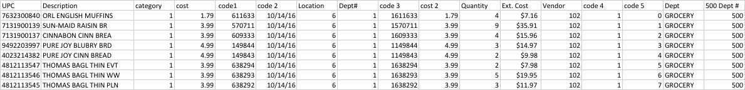

Figure 1. PICS inventory file October 2016 sample

* This information is based on the PICS inventory file result

# GOLD solution integration

## General Process Solution

When the physical count file is ready to be published. A designated user drops the file in GOLD. A scheduled process is sweeping and processing the file the day of the inventory.

### Publish the count file

|  |  |
| --- | --- |
| Menu Path | MENU: Administration > File Transfer |

|  |
| --- |
| Procedures |
| This step is initializing a new perpetual.     1. Click on CHANGE and browse to the inventory file folder 2. Select the inventory file 3. Validate the selection   Once the step 3 is performed, the file is uploaded in the inventory count queue. If you have multiple inventory files to be uploaded, make sure they are a different filename. |

* The inventory file must be saved in CSV format with comma-delimiter.
* If User is not able to upload the file, he can contact the Heinen’s Help Desk.
* Workaround is to share the count file with an IT profile.

### File processing and integration

The third-party count file is processed through GOLD out of the box Inventory connector INTINV. Once the file is processed, the store items inventories are updated with a stock movement 125- Inventory.



## Detailed solution

### Configuration

The solution process will use the third-party GOLD inventory type. This type is defaulting using the entry below:

* Parameter table 1309 entry 12 – Numerical Value 1 contains the default inventory type used for third party counting.

Inventory type have the below conditions defined:

* Condition 100 -Init by HHT
* Condition 101 – Init. By interface

### Item look-up

During the interfacing process, the item code is retrieved through the rules below:

1. Using the UPC code
2. If not found using the UPC code, the item code/commodity code is used. The last sale variant of the item is selected.

### Data count analysis

The inventory file can contain partial or incorrect information:

* Counts with UPC code, no item code, no inventory date
  + Those lines are integrated using the UPC code for the batch process date ran:

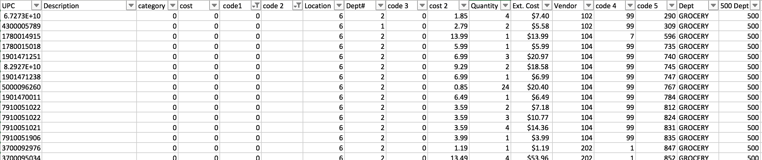

Figure 2. Code2 column contains the inventory data

* Counts with incorrect inventory date
  + Those lines are integrated using the UPC code for the batch process date



Figure 3. Code2 column contains the inventory data

### Batch & Schedule

The inventory must respect the GOLD batch integration PSIFA98P (Inventory interface) rules:

* The counting date must be equal to the batch processing date

At the end of the process, the item will have the counted quantity in the store inventory. Any inventory operations between the physical counting kick-off to the batch processing should be refrained, that includes:

* No damages/donation
* No receiving
* No returns
* Sales can be physically performed; Sales are uploaded after the count file integration.

The batch scheduling will happen in 2 steps as given below.

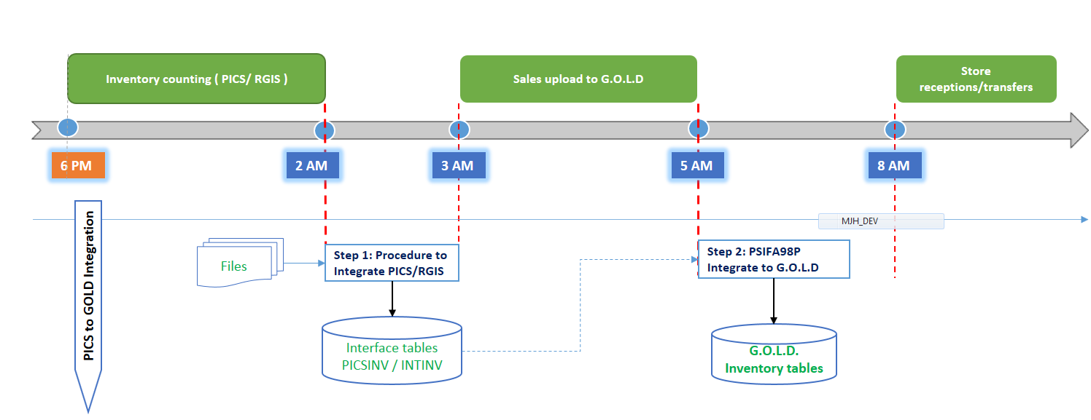

### Performance test result

Test date: 03/20/2017 Environment: UAT

Inventory type:

* Condition 100
* Condition 101

|  |  |
| --- | --- |
| Store # | Nb lines item |
| 17 | ﻿25600 |
| 6 | 24456 |
| 21 | 13215 |
| 20 | 24490 |
| 7 | 24171 |
| 15 | 24422 |
| 14 | 25555 |

|  |  |  |  |  |
| --- | --- | --- | --- | --- |
|  | Volume  (nb line item) | Nb stores | Duration | Comment |
| Step 1. Drop the file in the server (GOLD entry: Administration > File transfer) | | | | |
| 1. Drop the file | 161900 | 7 | 37 sec. | Using GOLD Screen - Administration > File Transfer |
| Step 2. Load the File into the database | | | |  |
| 2.Load data to SQL | 161900 | 7 | 2 sec. | Using SQL loader option DIRECT=YES (grab all and post in database table) |
| Step 3. Process the raw data to GOLD interface table | | | |  |
| 3a. SQL to GOLD (All stores) | 161900 | 7 | 40 min | Mapping between raw file to GOLD interface INTINV table |
| 3b. SQL to GOLD (1 store) | No capability  (capability by filename) | | | If team decision, add the site # as a parameter for performance improvement |
| Step 4. Integrate the PI into GOLD internal table | | | | |
| 4a. GOLD Interface processing (All stores) | 161900 | Not ran | Not ran |  |
| 4b. GOLD Interface processing (1 store) | 24000 | 1 | 26 min | Test on store #6 |
| 4c. GOLD Interface processing (5 stores in parallel) | ~24000/store | 5 | 9 min => 50 min | Running same batch by PI id # (5 stores in parallel) - Store #17, 21, 20, 7, 15 |

# Glossary of Terms

|  |  |
| --- | --- |
| Term | Definition |
| Inventory | GOLD terms to designate counting operations. Synonym in GOLD, cycle-count, inventory, perpetual. |
|  |  |
|  |  |
|  |  |

# Section Approval

## Approval – Design

|  |  |  |  |
| --- | --- | --- | --- |
| Role | Name | Signature | Date |
|  |  |  |  |
|  |  |  |  |